

Project Name: Online Auction System

Branch C-DAC Sept-2022

Documentation On

**“ONLINE AUCTION SYSTEM”**

C-DAC SEPT 2022

**Guided By: Snehal Somwanshi**

Submitted By :

**Group No: 12**

* **Rahul Muttanwar 220043020056**
* **Rohit Patil 220043020065**
* **Paroksh Potdar 220043020068**
* **Saurabh Wani 220043020113**

**Table of Contents**

**1. Introduction 4**

1.1 Document Purpose **4**

1.2 Project Background **4**

1.3 Aim & Objectives **4**

**2. Business Requirements Overview**…………………………………………………………**5**

**3.Functional Requirements** 5

3.1 Seller Module 5

3.2 Bidder Module 5

3.3 Admin Module **6**

**4.** **Non-Functional Requirement………………………………………………………………6**

**5. Use Case Diagram 7**

5.1 Admin 7

5.2 Seller 8

5.3 Bidder 9

**6. Database Design 10**

1 User **10**

2 User Type **10**

3 Question………………………………………………………………………………… **10**

4 Product **11**

5 Bidding Transaction **11**

6 Bidding Table **11**

7 Product sold **12**

8 Category **12**

9 Feedback **12**

10 Message **13**

**7. E-R Diagram………………………………………………………………………………………14**

**8. Snapshots 15**

**9. Conclusion 26**

**List of Figures**

**Use Case Diagrams 17**

Fig 1 Admin 8

Fig 2 Seller 9

Fig 3 Bidder 10

Fig 4 ER Diagram 14

1. **Introduction:**
   1. **Document Purpose:**

This document communicates the business requirements and scope for developing Online Auction System. The scope of this document is to define the functional and non functional requirements, business rules and other constraints requirements.

## Project Background:

There is no computerized system for auctioning valuable products. Currently, the seller goes to nearest auctioning house or sell the product directly without auctioning online or offline, in both online and offline selling of product there are chances of bargaining for price by buyer. There are chances of frauds in case of selling valuable products online for both buyer and seller. Seller can only fix a price for selling and in some cases, buyers tends to bargain for the product. There is no way for buyer to check where the product is genuine or stolen. No facility is present for both buyers and sellers to detect chances of fraud during buying or selling.

## Aim & Objectives:

The main objective of this project is building a website which will help buyers and sellers to participate in auction. Here if suppose some seller or buyer want to use this facility and learn how is it possible and how they can use Online Auction System to buy or sell the products, they must have knowledge of computer then they can directly register in the site and sell or buy the products online.

1. **Business Requirements Overview:**

* Online Auction System is the public web application.
* There are mainly two types of users. One is the Buyer or Bidder and other is Seller.
* Bidders can search for the category of the products
* Bidders/Buyers can search for the products available in the auction and even the information about the seller
* Online Auction System provides the functions which connect the sellers and the bidders efficiently.
* Online Auction System could be maintained by Administrator.

# Functional Requirements Overview:

Online Auction System consists of three modules described as bel

1. Seller Module
2. Bidder Module
3. Admin Module

# **3.1 Seller Module**

* Seller can register and create his own account.
* Online Auction System provides the function which allows Sellers to add their products for auction.
* Seller can set base price for the product added.
* The Seller can end the auction.
* The Seller can see the current bid price on the product added.

# **Bidder Module**

* Bidder can register and create his own account.
* Online Auction System provides the function which allow buyers to bid on product and see the description of product.
* bidder can see sellers rating for authenticity
* Bidder can rate the product and seller

# **3.3 Admin Module**

* Online Auction System should provide all functions to admin how to handle the System.
* Admin can check KYC and authorize bidder/buyers and sellers based on Government Identity proof.
* Admin can verify every product before it goes for auctioning.
* Admin can remove fraud Sellers and Buyers.

1. **Non-Functional Requirement:**

* The website should use professional design, look and feel and color scheme.
* Users will have no limitations for accessing the application through Internet. The portal being an internet application, it is difficult specify exact number of visitor or users. Hence we will target the system to support multiple users .

* Being a public website, the site must follow general usability guidelines for menus, navigation, colors, links and other actions provided on the screens.
* The system should be designed in such a manner that user will be able to complete tasks in minimum number of steps.

.

## 5. Use-Case Diagram

**5.1 Admin:**

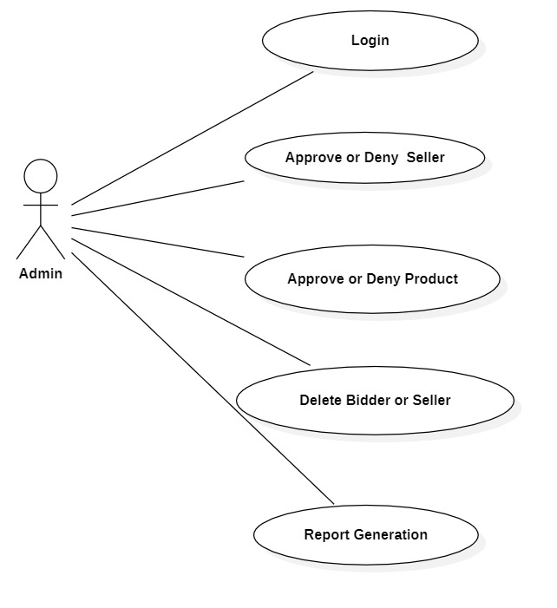

Fig. Use-Case Diagram for Admin

## 5.2 Seller:

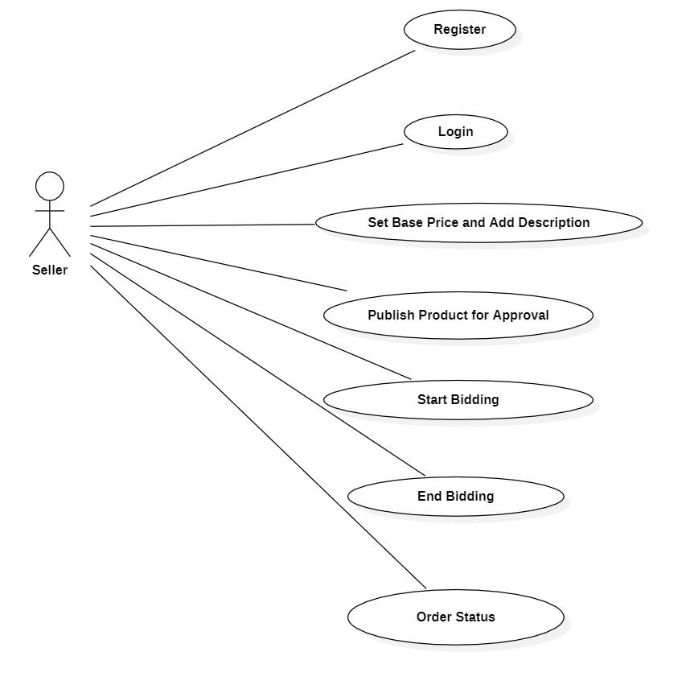

Fig. Use-Case Diagram for Seller

**5.3 Bidder:**

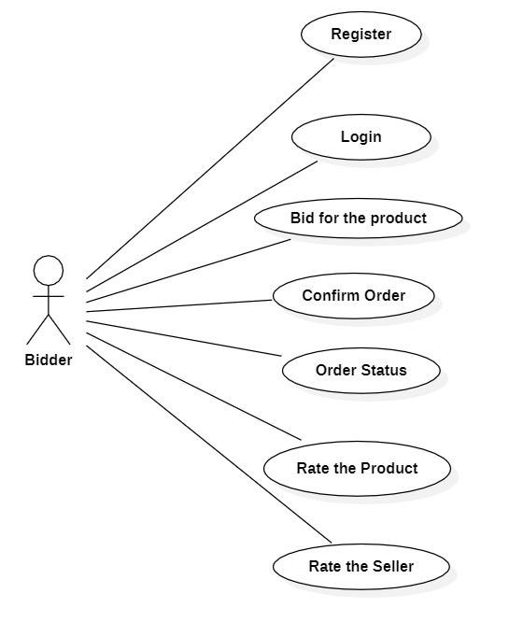

Fig. Use-Case Diagram for **Bidder**

**6. Database Design:**

1. **User_Table**

|  |  |  |  |  |  |
| --- | --- | --- | --- | --- | --- |
| **Field** | **Type** | **Null** | **Key** | **Default** | **Description** |
| user_id | Integer | No | Primary key |  | User ID |
| user_type_id | Integer | No | Foreign Key |  | User Type Id (Reference to User_Type table Seller/Bidder/Admin) |
| fname | Varchar(45) | No |  |  | First Name |
| lname | Varchar(45) | No |  |  | Last Name |
| email | Varchar(45) | No |  |  | Email ID Of User |
| mobile | Integer | No |  |  | Contact No. Of User |
| state | Varchar(45) | No |  |  | State of user |
| city | Varchar(45) | No |  |  | City of user |
| pincode | Varchar(10) | No |  |  | Pincode of user |
| address | Varchar(100) | No |  |  | Permanent Address |
| gender | Varchar(10) |  |  |  | Gender Information |
| pan_card_no | Varchar(15) | No |  |  | Pan Card Number |
| pan_card_image | Long blob | No |  |  | Image of Pan Card |
| account_status | Varchar(45) | No |  |  | Account Status Enabled/ Disabled  (Initially Disabled for Seller) |
| q_id | Integer | No | Foreign  Key |  | Question Id for Forget Password |
| answer | Varchar(100) | No |  |  | Answer for Selected Question (User Specific) |
| username | Varchar(45) | No |  |  | Username of user |
| password | Varchar(45) | No |  |  | Account Password |

1. **User_Type**

|  |  |  |  |  |  |
| --- | --- | --- | --- | --- | --- |
| **Field** | **Type** | **Null** | **Key** | **Default** | **Description** |
| user_type_id | Integer | No | Primary key |  | User Type Id  (Admin/Seller/Bidder) |
| user_type | Varchar(45) | No |  |  | Admin, Seller, Bidder |

1. **Question_Table**

|  |  |  |  |  |  |
| --- | --- | --- | --- | --- | --- |
| **Field** | **Type** | **Null** | **Key** | **Default** | **Description** |
| q_id | Integer | No | Primary key | Null | Question Id |
| question | Varchar(100) | No |  | Null | Question |

1. **Product**

|  |  |  |  |  |  |
| --- | --- | --- | --- | --- | --- |
| **Field** | **Type** | **Null** | **Key** | **Default** | **Description** |
| P_Id | Integer | No | Primary key |  | Product Id |
| product_name | Varchar(45) | No |  |  | Product name |
| category_id | Integer | No | Foreign Key |  | Category id |
| description | Varchar(200) | No |  |  | Description of product |
| product_image_1 | Long Blob | No |  |  | Product Image1 |
| product_image_2 | Long Blob | No |  |  | Product Image2 |
| product_image_3 | Long Blob | No |  |  | Product Image3 |
| base_price | Decimal(9,2) | No |  |  | Base Price of the product |
| seller_id | Integer | No | Foreign Key |  | Seller Id |
| start_date | Datetime | No |  |  | Bidding Start date |
| end_date | Datetime | No |  |  | Bidding End date |
| status | Varchar(45) | No |  |  | Approved/Pending |

1. **Bidding Transaction**

|  |  |  |  |  |  |
| --- | --- | --- | --- | --- | --- |
| **Field** | **Type** | **Null** | **Key** | **Default** | **Description** |
| bidding_transaction_id | Integer | No | Primary Key |  | Bidding Id |
| P_Id | Integer | No | Foreign key |  | Product Id |
| bidder_id | Integer | No | Foreign Key |  | Base Price for the product |
| bid_price | Decimal(9,2) | No |  |  | Bidding price |
| bid_time | Datetime | No |  |  | Date of the Bid |

1. **Bidding Table**

|  |  |  |  |  |  |
| --- | --- | --- | --- | --- | --- |
| **Field** | **Type** | **Null** | **Key** | **Default** | **Description** |
| bid_id | Integer | No | Primary key |  | Bid id |
| P_Id | Integer | No | Foreign Key |  | Product Id |
| base_price | Decimal(9,2) | No | Foreign Key |  | Base price |
| bidder_id | Integer | No | Foreign Key |  | Bidder id |
| start_date | DateTime | No |  |  | Bidding TimeStamp |
| end_date | DateTime | No |  |  | Bidding Start date |
| final_bid_price | Decimal(9,2) | No |  |  | Bidding End date |
| bidding_status | Varchar(45) | No |  |  | Bidding status(payment) |

1. **Product Sold**

|  |  |  |  |  |  |
| --- | --- | --- | --- | --- | --- |
| **Field** | **Type** | **Null** | **Key** | **Default** | **Description** |
| sold_pid | Integer | No | Primary key |  | Sold product id |
| bid_id | Integer | No | Foreign Key |  | Bid id |
| sold_date | Datetime | No |  |  | Date at which product sold |
| payment_mode | Varchar(45) | No |  |  | Payment mode of buyer |
| payment_transaction_id | Varchar(45) | No | Foreign Key |  | Transaction ID |
| delivery_status | Varchar(45) | No |  |  | Status after product get sold |

1. **Category Table**

|  |  |  |  |  |  |
| --- | --- | --- | --- | --- | --- |
| **Field** | **Type** | **Null** | **Key** | **Default** | **Description** |
| category_id | Integer | No | Primary key |  | Category Id |
| category_name | Varchar(45) | No | Foreign key |  | Category name |

1. **Feedback Table**

|  |  |  |  |  |  |
| --- | --- | --- | --- | --- | --- |
| **Field** | **Type** | **Null** | **Key** | **Default** | **Description** |
| Feedback_Id | Integer | No | Primary key |  | Feedback Id |
| P_Id | Integer | No | Foreign key |  | Product Id |
| Seller_Id | Integer | No | Foreign key |  | Seller Id |
| Bidder_Id | Integer | No | Foreign Key |  | Bidder Id |
| Seller_Rating | Integer | No |  |  | Seller Rating |
| Product_Rating | Integer | No |  |  | Product Rating |
| Feedback_Description | Varchar(300) | No |  |  | Feedback Description |

1. **Message Table**

|  |  |  |  |  |  |
| --- | --- | --- | --- | --- | --- |
| **Field** | **Type** | **Null** | **Key** | **Default** | **Description** |
| message_id | Integer | No | Primary key |  | Messege Id |
| P_Id | Integer | No | Foreign key |  | Product Id |
| user_id | Integer | No | Foreign Key |  | Bidder Id |
| bid_id | Integer | No | Foreign Key |  | Bid ID |

## 7. ER-Diagram:

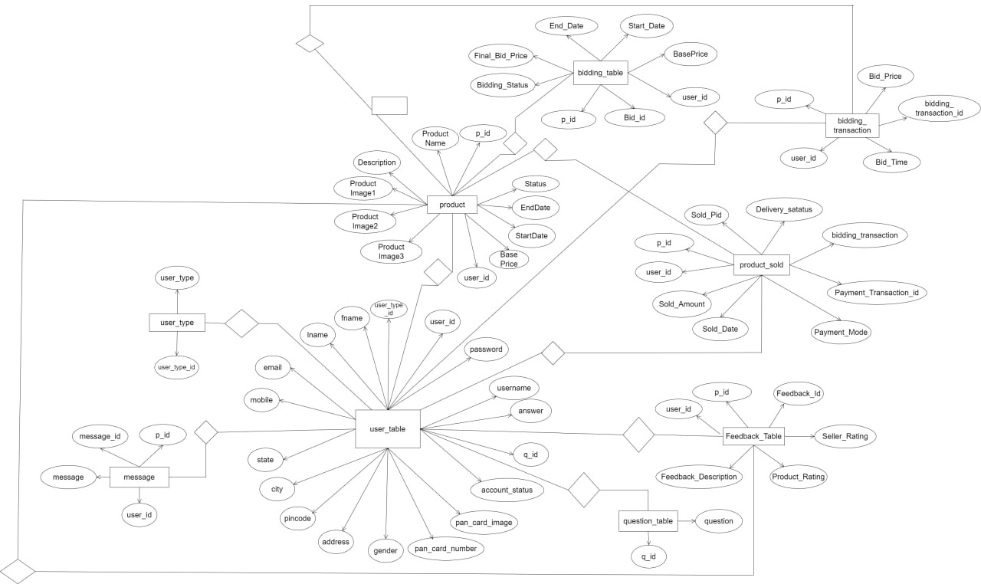

**E-R diagram shows database of Online Auction system**

**8. Snapshots:**

**8.1 Home Page:**

Following snapshot shows the Home page for Online Auction System

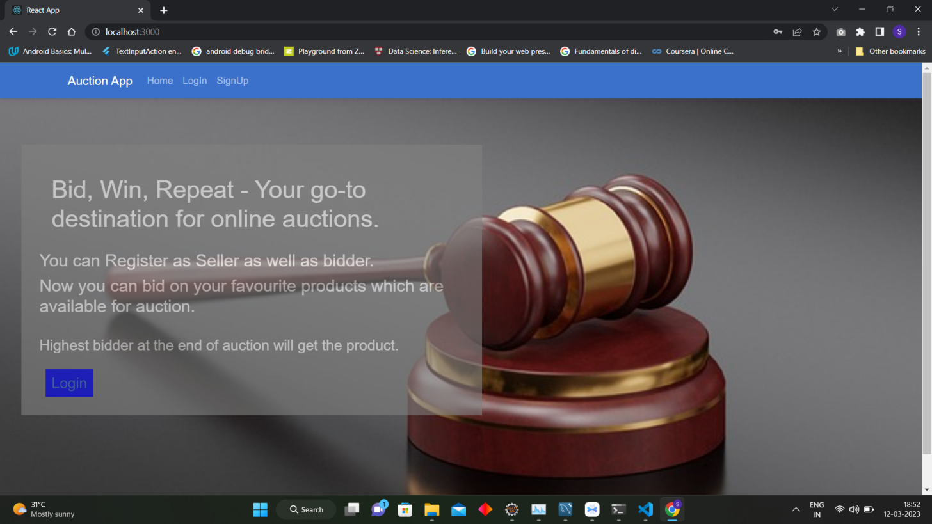

This page contains following controls

* Login
* Sigh Up

**8.2 Login Page**

Following snapshot shows the Login page for Online Auction System

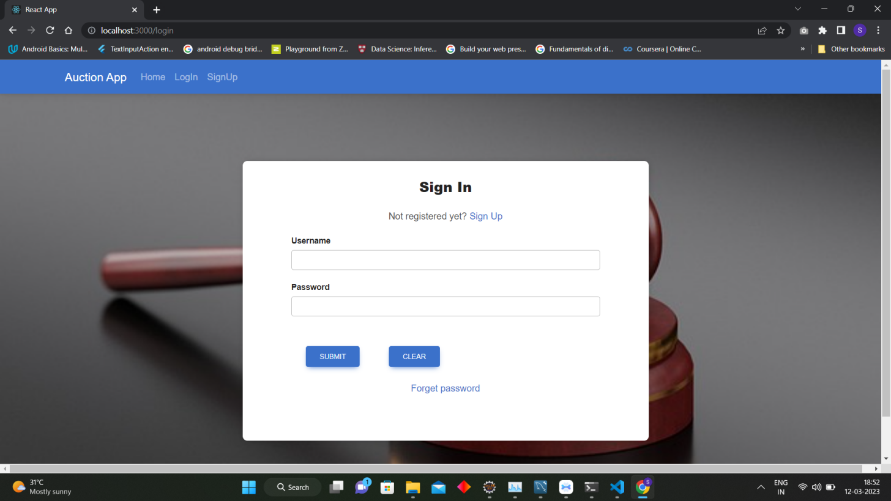

**8.3 User Registration Page**

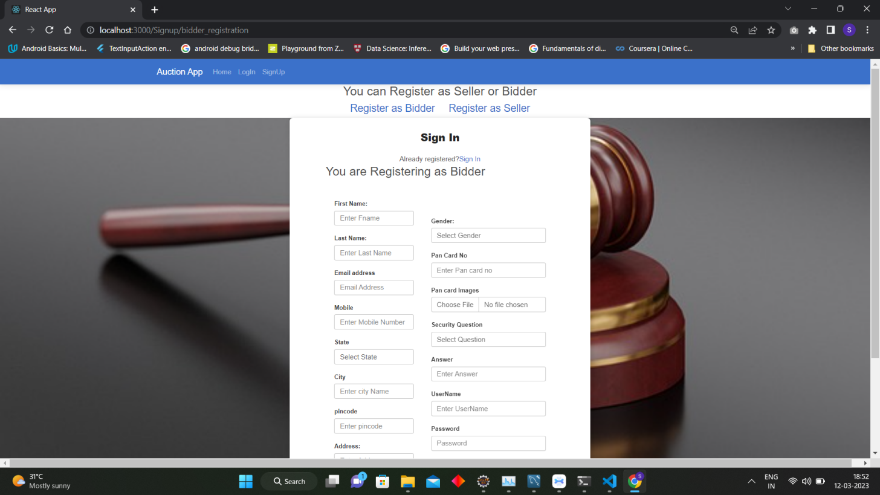

**8.4 Admin Home Page**

**8.4.1 Admin Home Page**

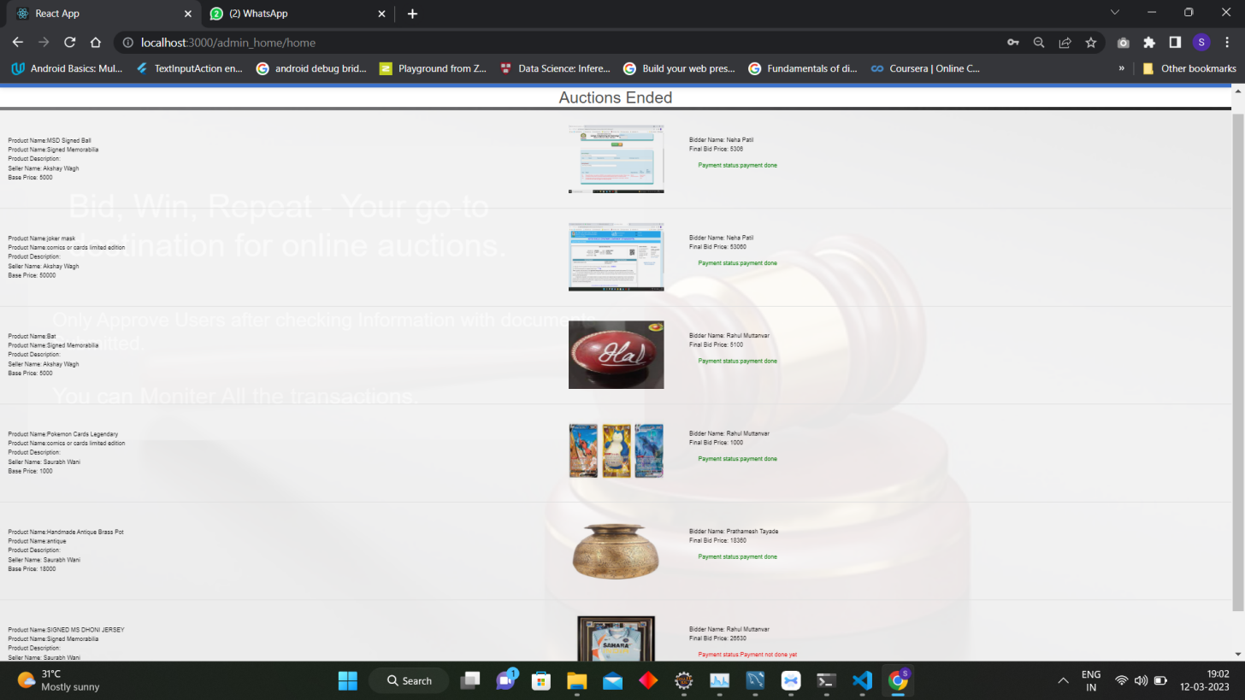

**8.4.2 Pending Product for Approval**

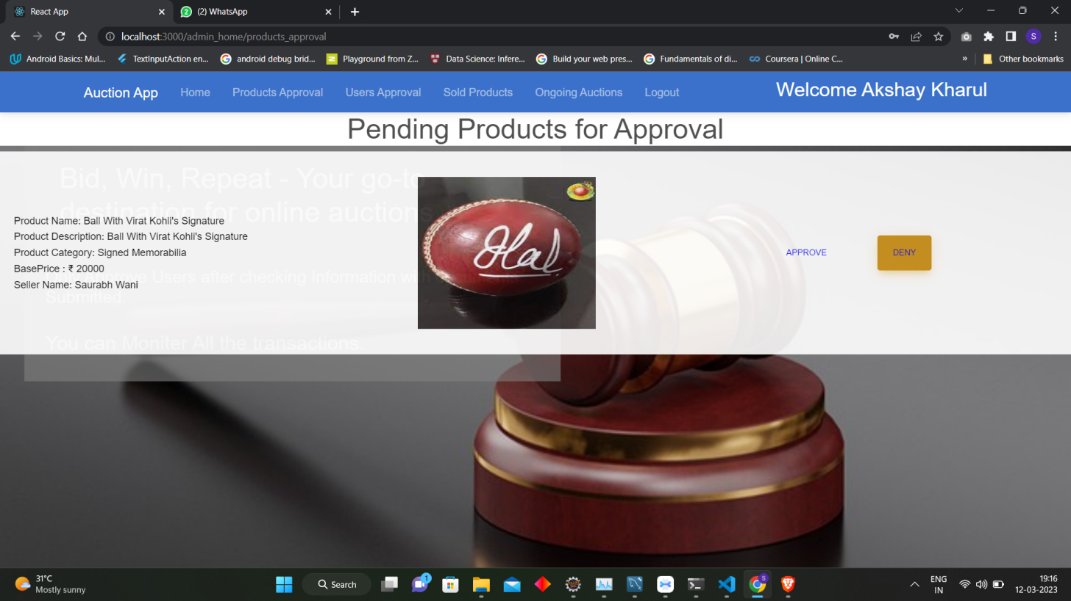

**8.4.3 Pending Uusers for Approval**

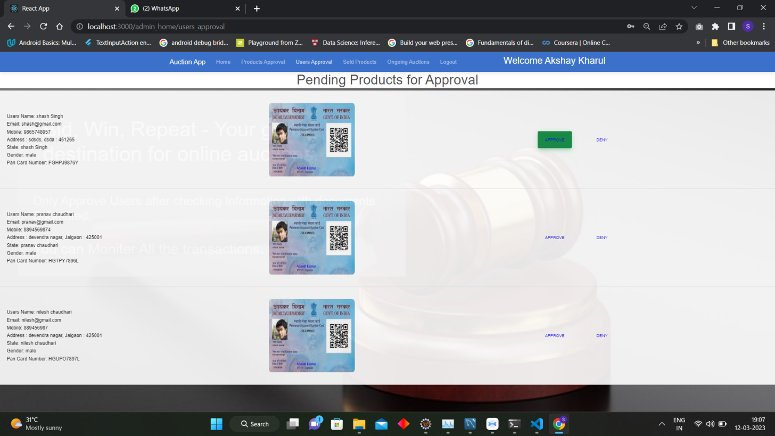

**8.4.4 All Sold Product**

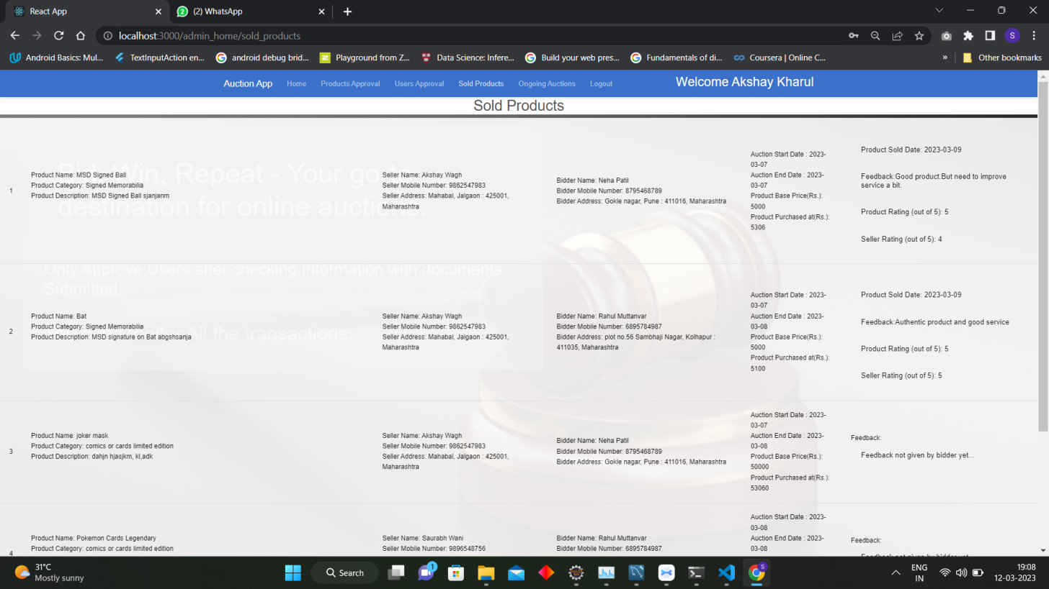

**8.4.5 All ongoing Auctions**

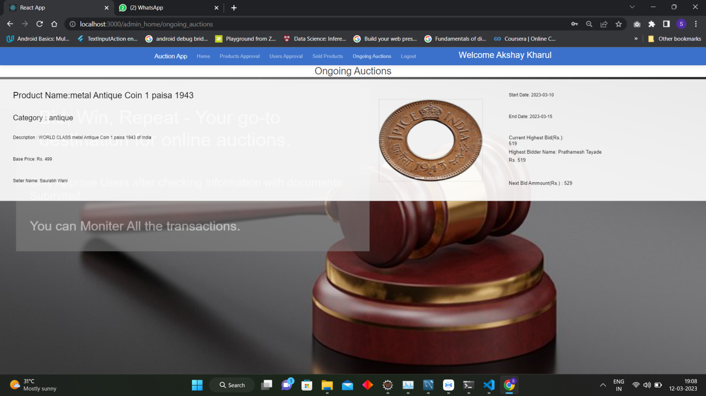

**8.5 Seller Home Page**

**8.5.1 Seller home page**

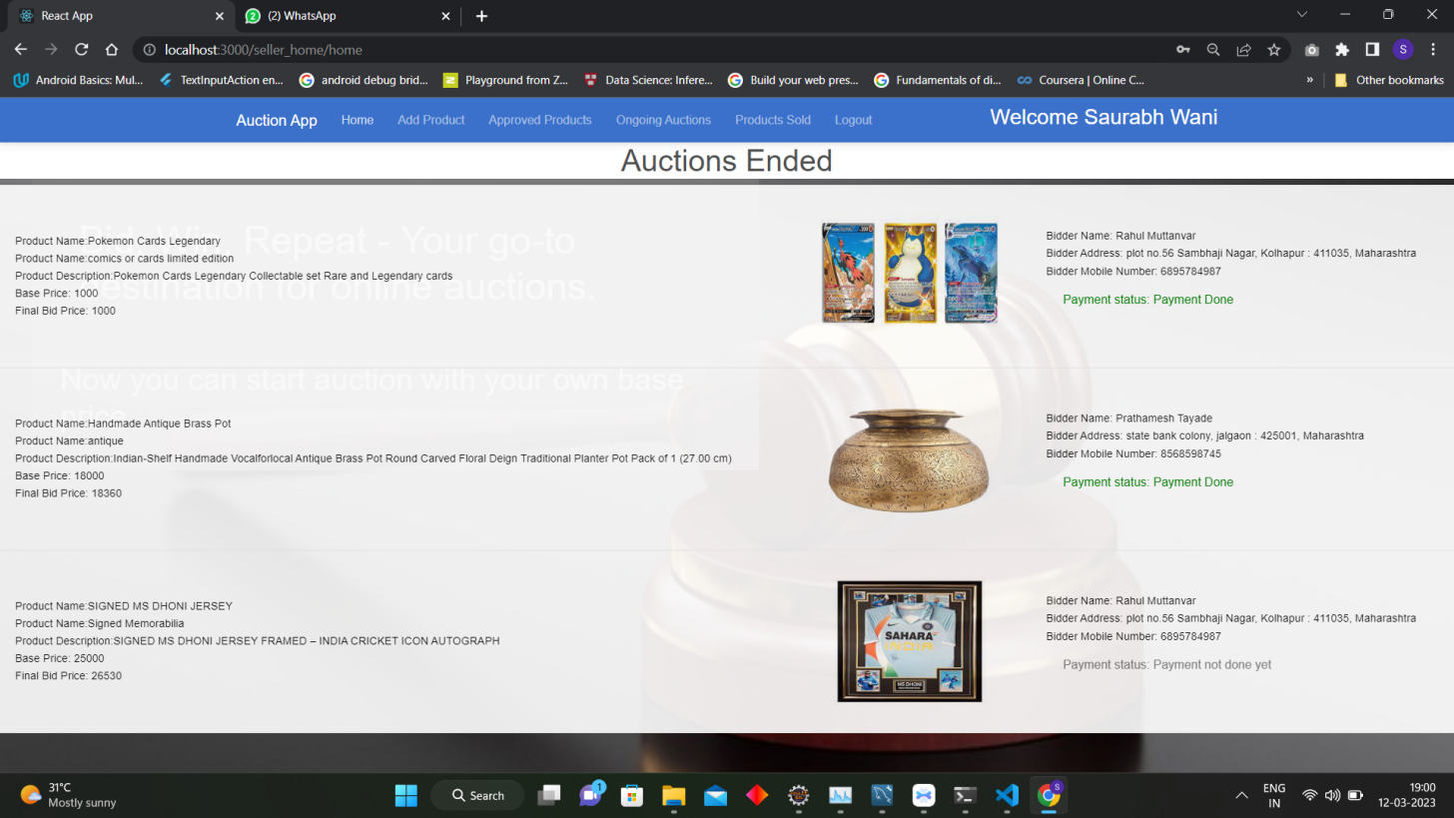

**8.5.2 Adding product for auction**

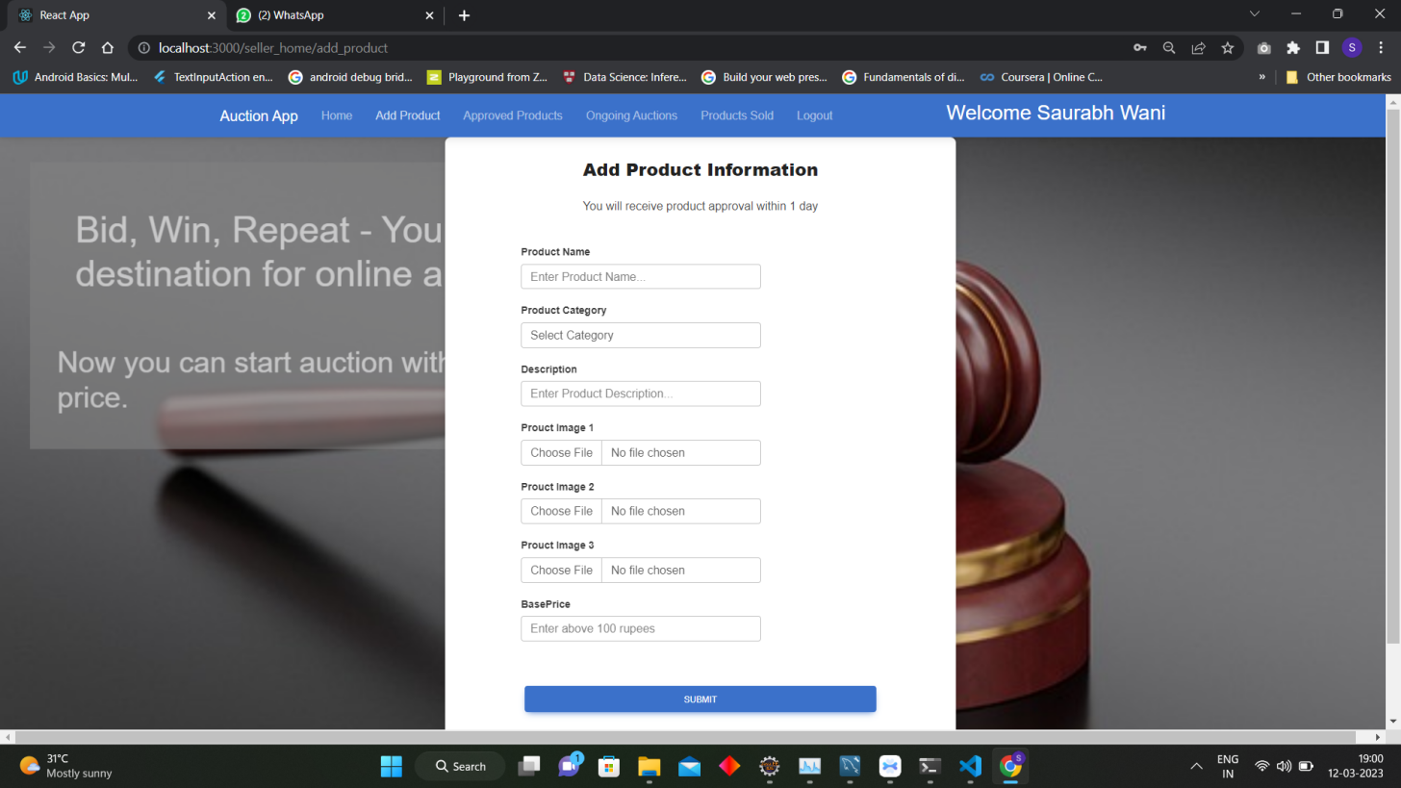

**8.5.3 Product Approved by Admin for selling**

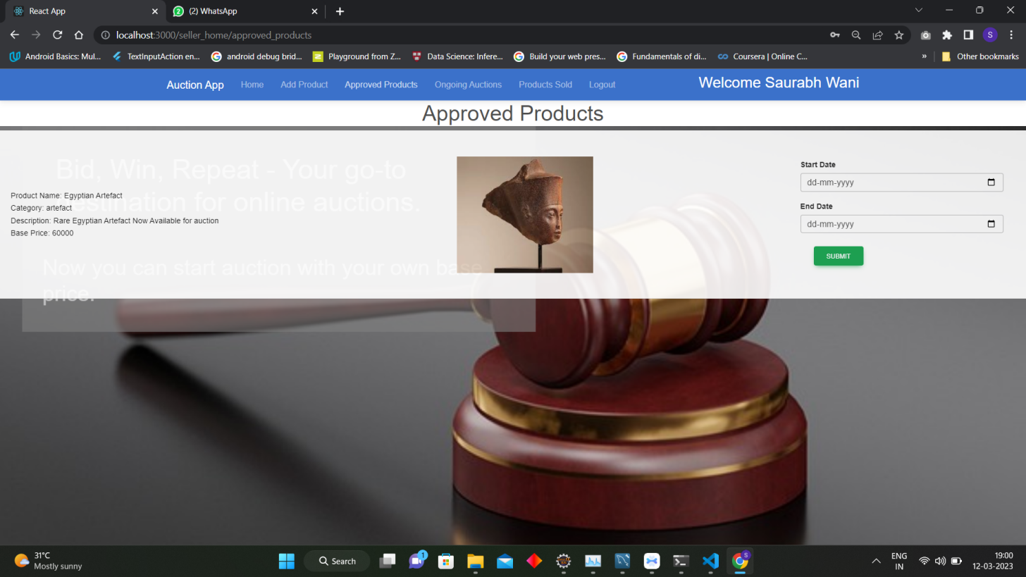

**8.5.4 Ongoing Auction of product**

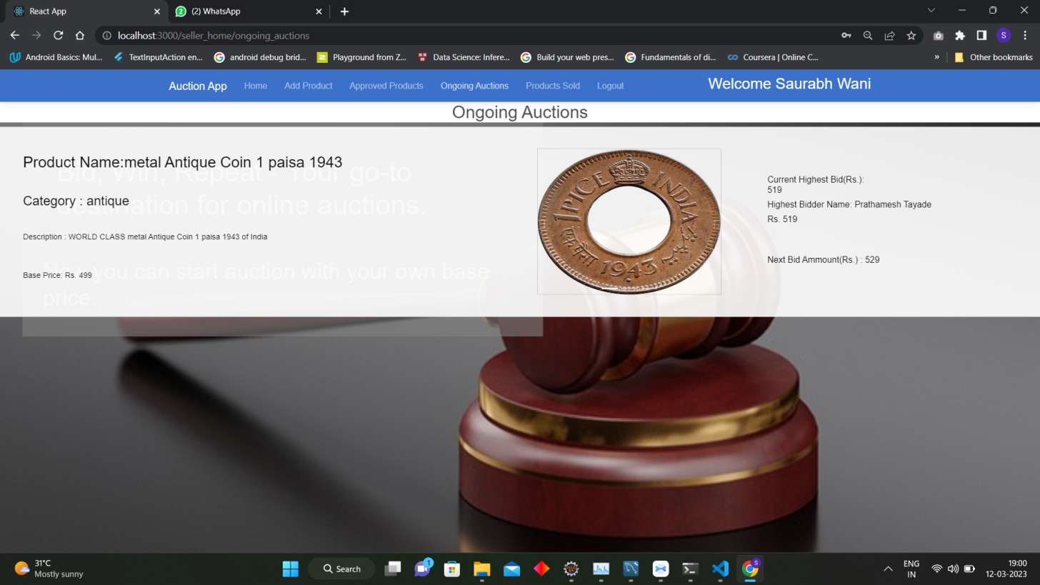

**8.5.5 Product sold by the Seller**

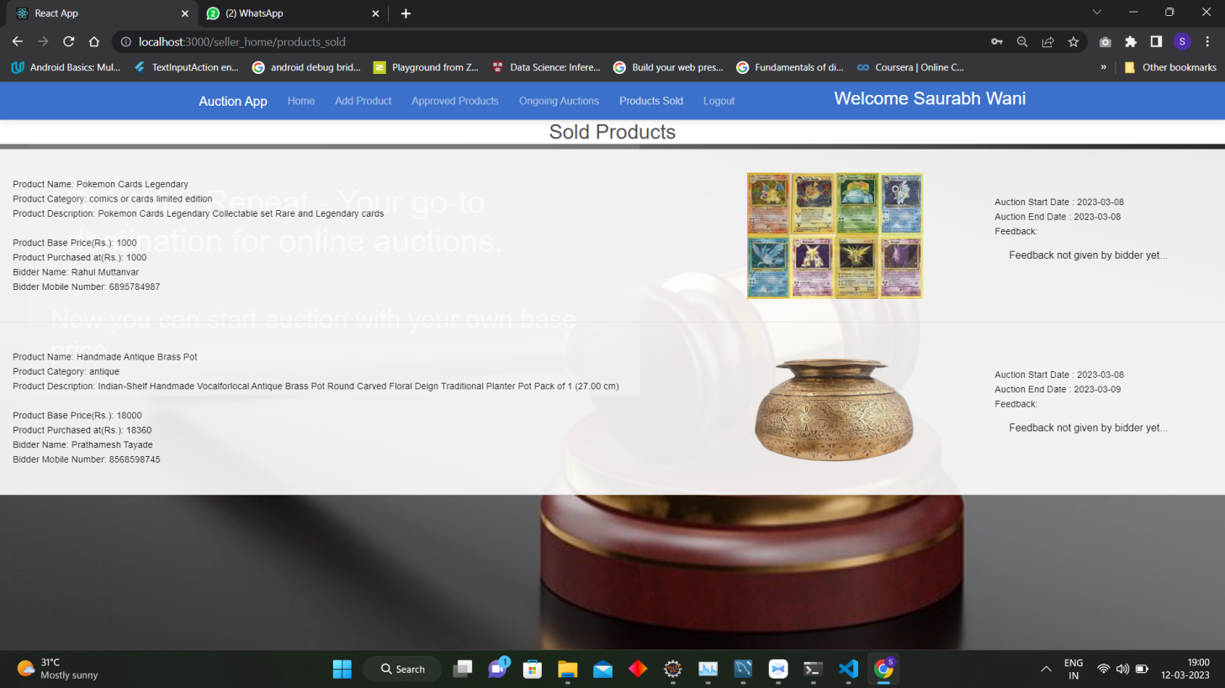

**8.6 Bidder Home Page**

**8.6.1 Bidder home page**

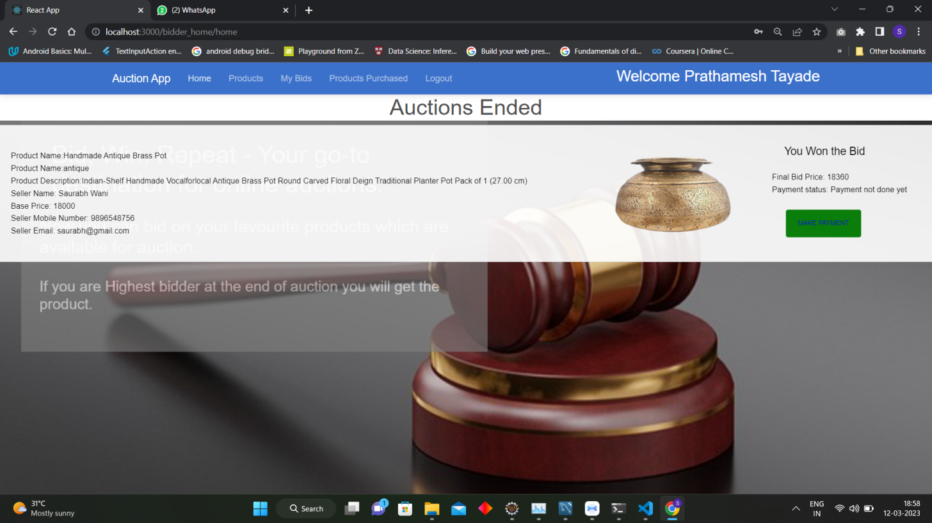

**8.6.2 Product won after bidding**

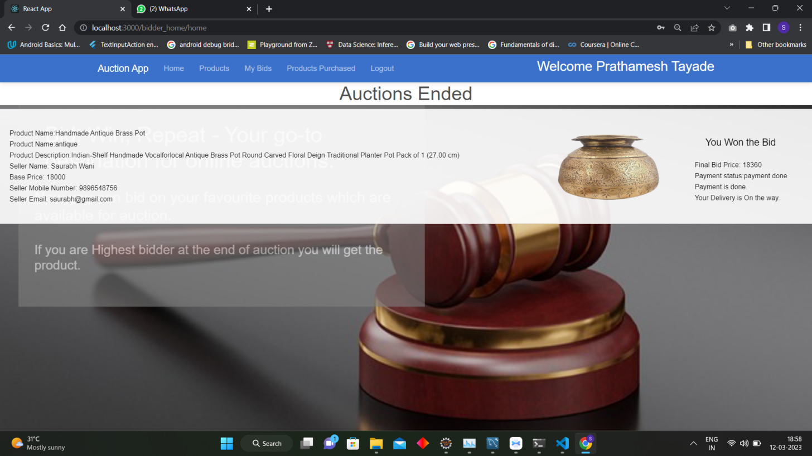

**8.6.3 Products available for bidding**

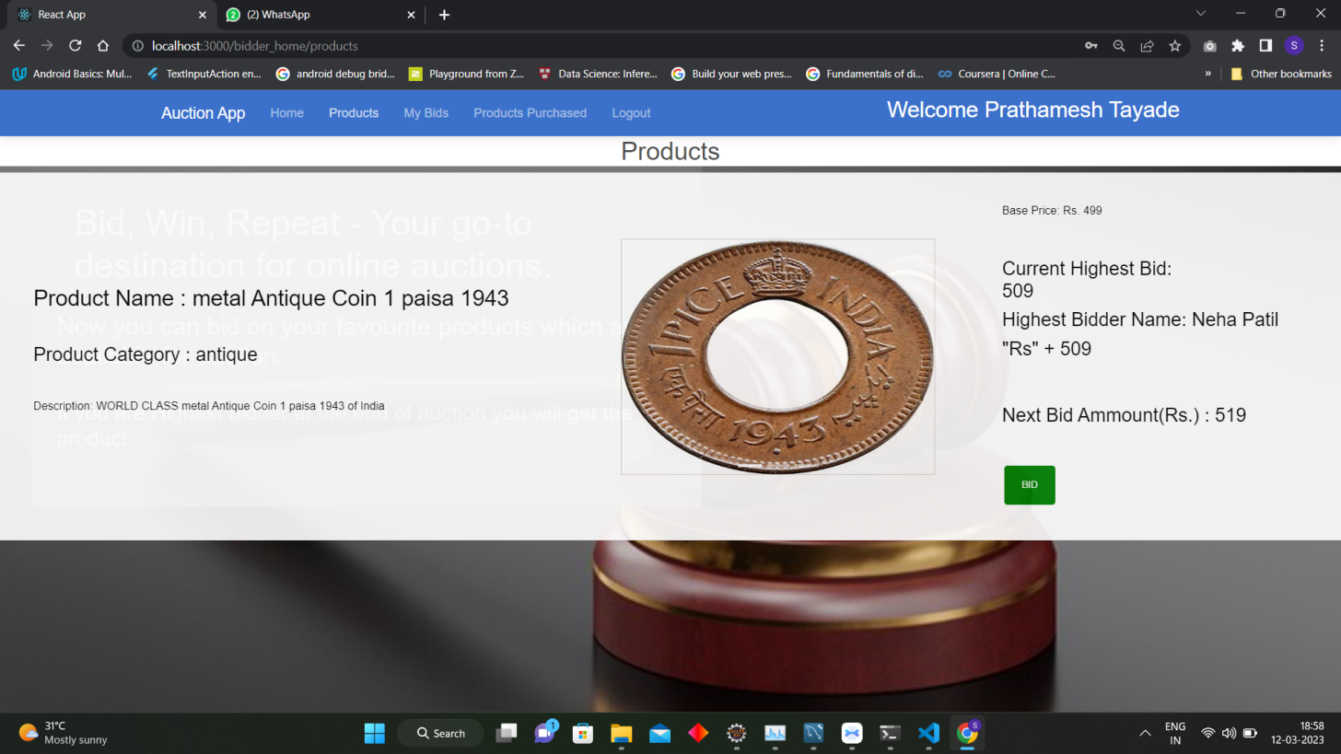

**8.6.4 My Bid Page**

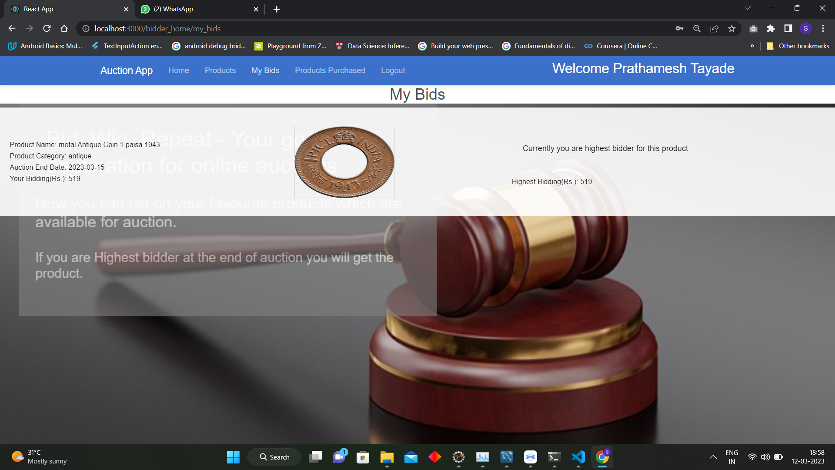

**8.6.4 Product purchased Page**

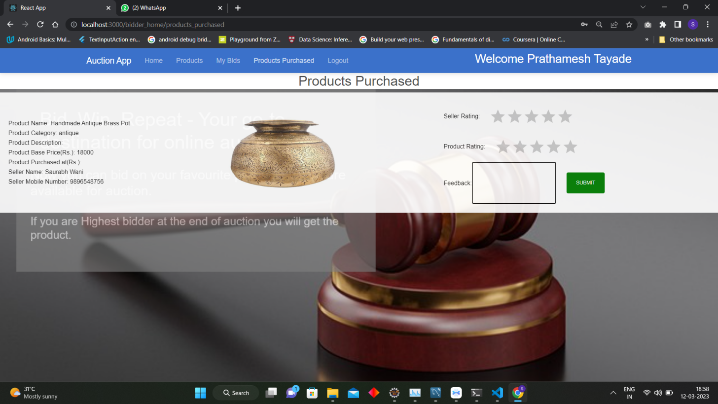

1. **CONCLUSION AND FUTURE SCOPE**

Online auction websites have revolutionized the way we buy and sell goods. With the increasing popularity of e-commerce and the growing number of internet users, the future of online auctions looks bright. By expanding to new markets, integrating with social media, optimizing for mobile devices, integrating blockchain technology, and using artificial intelligence, online auction websites can continue to grow and provide a convenient and secure platform for buyers and sellers..

The future of online auction websites is bright, as more and more people are turning to online platforms for buying and selling goods. With the growth of e-commerce and the increasing use of smartphones, the online auction industry is expected to continue to expand. Some of the potential areas of growth in the online auction industry include:

Expansion to new markets: Online auction websites can expand their services to new regions and countries, thereby increasing their customer base and revenue.

Integration with social media: Integrating online auction websites with social media platforms can help reach a wider audience and increase engagement.

Mobile optimization: With the increasing use of smartphones, online auction websites must be optimized for mobile devices to provide a seamless user experience.